5DATA005W DATA ENGINEERING
Tutorial Week 8: Unstructured data; preprocessing

Reminder: Have you swiped your card? You can swipe in no earlier than 15 minutes before the tutorial and up to 15 minutes before your class ends. Ensure you see a green tick and your student ID number on the reader.

Objective: In this lab session, you will learn:
- Image preprocessing
- Text preprocessing

We will use Google Colab - Python IDE. You will need to log in to use the Google Colab. You can use your university email or your personal.

Image preprocessing
Images, like other forms of data, can also pass through the data pipelines, meaning images can be ingested, transformed and loaded into storage. This section is mainly focused on ingestion and transformation.

- Download the fruit image from the BB.
- Upload the data to your Colab.
- Import all the necessary libraries.
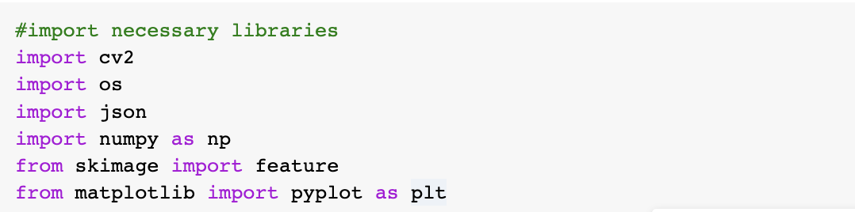

- Ingest image data
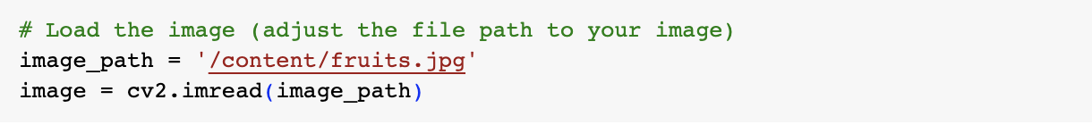
You may want to copy the image data file path from collab and replace ‘/content/fruits.jpg’.

- Display the image
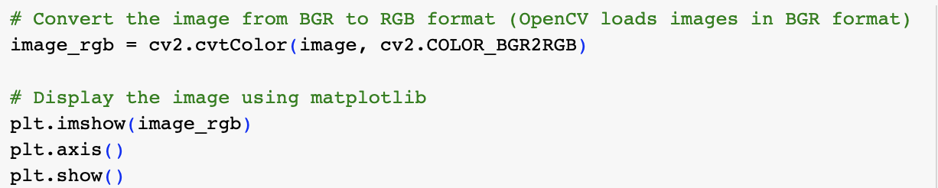
OpenCV loads images in BGR format, as such, there is a need to change BGR to RGB.

Now, let’s begin to transform(preprocess) the image.
- Resize the image to a certain width * height
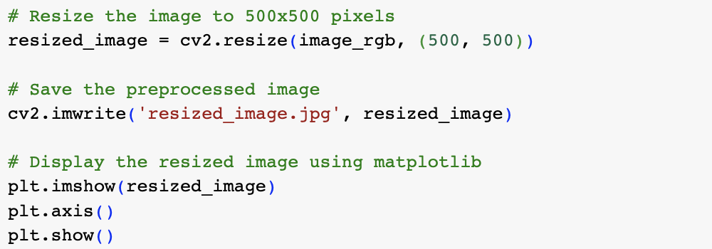
Here, the image was resized to 500 x 500, saved and then displayed.

- Rotate the image
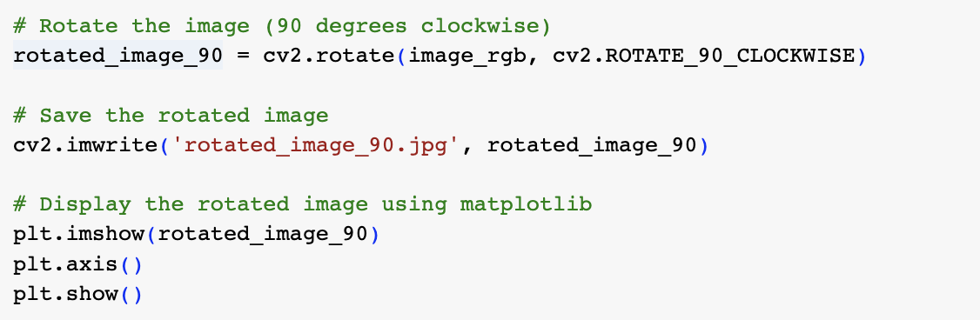
Here, the image was rotated 90 degrees clockwise, saved and then displayed. We can rotate it to other degrees to enhance the quality of the image.

- Denoise the image
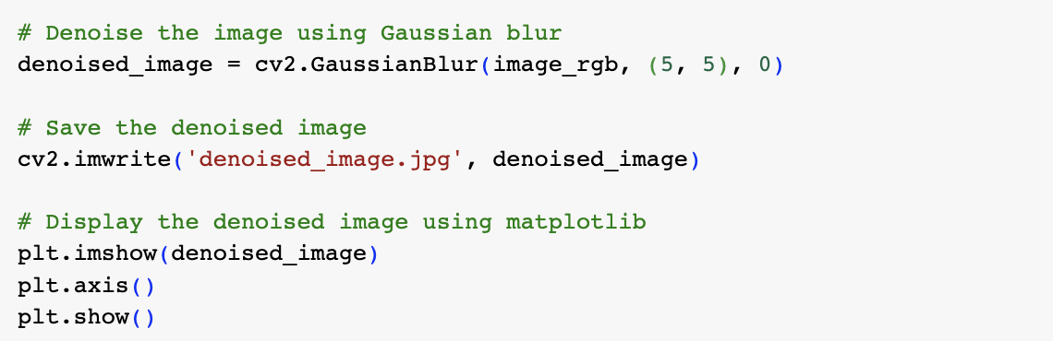
Here, the image was denoised using GaussianBlur, saved and then displayed.

You may have noticed that we've been using the original image_rgb file separately for each individual processing technique. Instead, let's try applying all the techniques in sequence—first resizing, then rotating, and finally denoising—to obtain a fully processed image.

- Apply resize, rotation and denoise on an image.
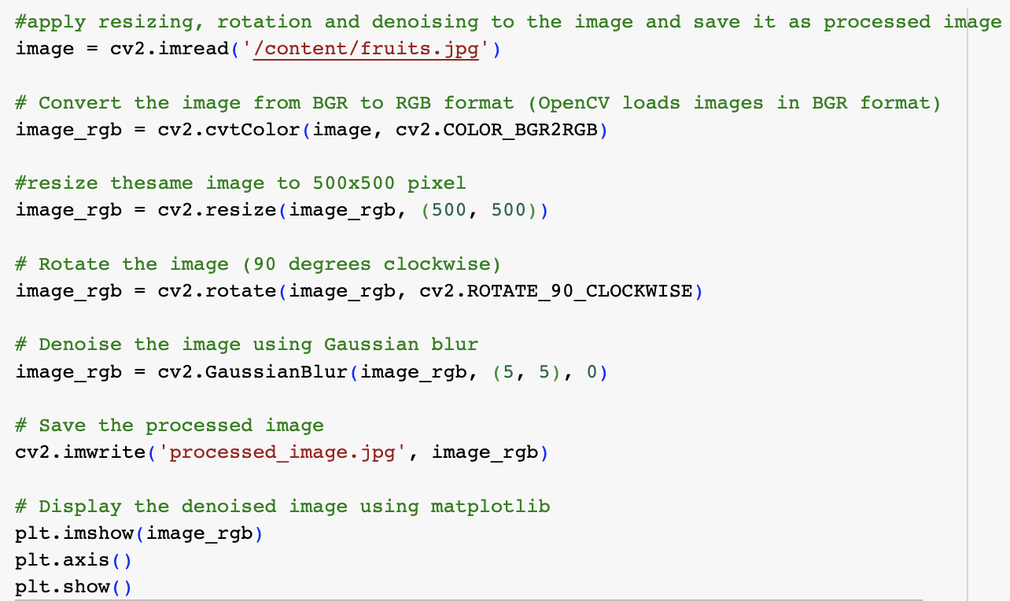
Here, we applied the techniques in a specific order: resizing the image, rotating, and finally denoising. However, you can follow a different sequence. Instead, choose the order and particular techniques that best enhance the image quality based on your needs.

The image was processed, saved and then displayed.

- Image Annotation
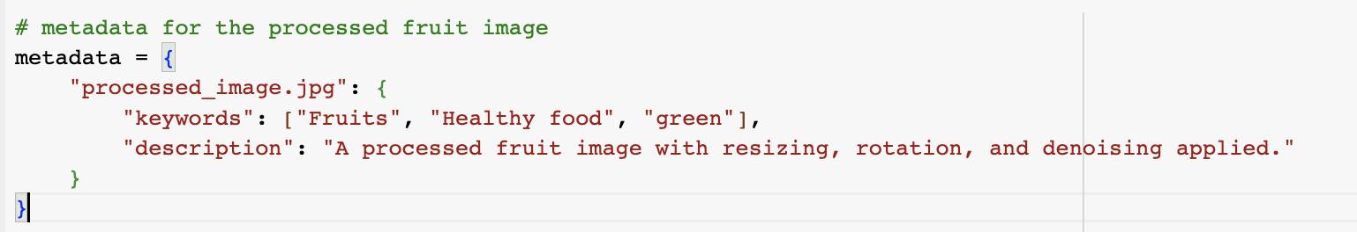
We manually created metadata(annotation) by making a dictionary with the image name as the key, containing keywords and descriptions.

- Save the metadata as a JSON file.
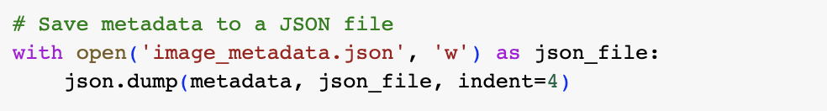
Here, the metadata is saved as a JSON file for later use.

Image Feature Extraction
Extract features such as mean intensity and norm intensity.

- Calculate the mean and norm intensity of the processed image.
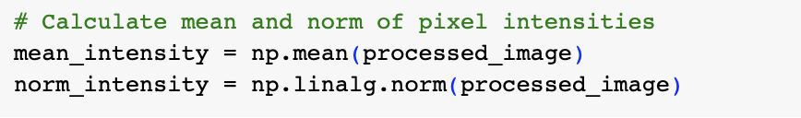
Here, calculate the processed data's mean and norm intensity. We saved the mean and norm as variables, each for later use.

- Extract shape features
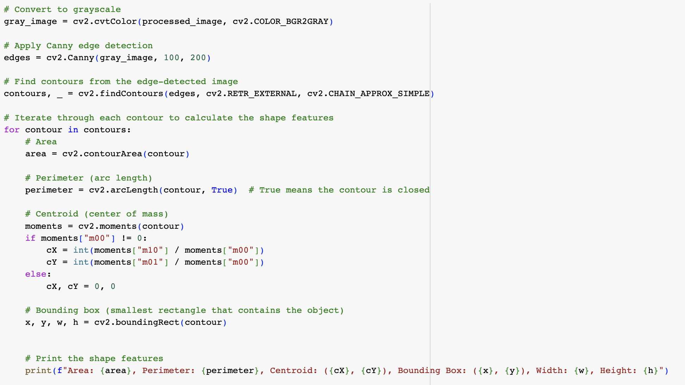
Here, we started by converting the image to grayscale, and then we computed the area, perimeter, centroid, and bounding box as examples of shape features.

- Metadata for all the image features extracted from tasks 12-13.
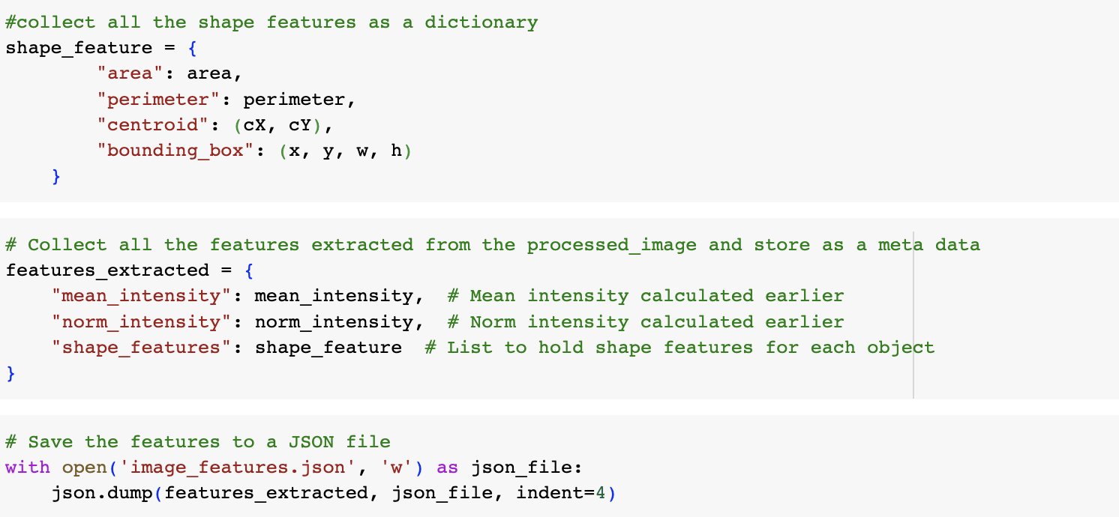Here, the shape features (area, perimeter, centroid, bounding box) were first put together and then combined with mean and norm intensity. All the image features were extracted and put together as a dictionary and metadata file for the processed image. The features extracted were saved as a JSON file for later use.

Text processing
This section focuses on text data's ingestion and transformation(preprocessing).

- Download the document named 101551 from the BB.
- Upload the data to your Colab.
- Import all the necessary libraries.
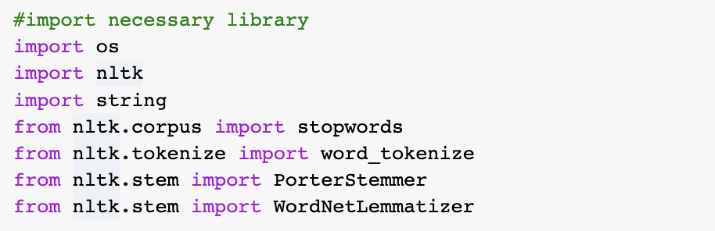

- Download stopwords and punkt tokeniser
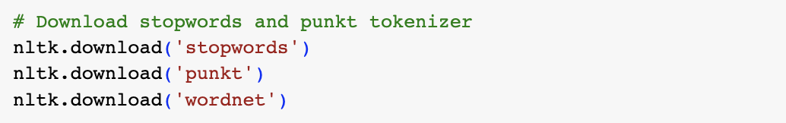
Here, we download the list of stop words for the English language. Note that each language typically has its own set of rules, so different languages may require their specific dictionary to identify stop words.

- Load the document file
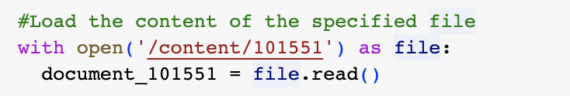

- Filter out some parts of the document and create data out of that.

We created new text data by filtering out the first 621 and last 15 characters.

Preprocessing Techniques:
- Text Normalization (Lowercasing)
- Tokenization & Removal of Punctuation and Stop Words
- Stemming reduces a word to its root or base form by removing prefixes and suffixes.
- Lemmatization reduces word to their dictionary base form (lemma)

- Convert the sample document to lowercase all through.
- Tokenise the sample document.

- Remove all punctuation marks from the tokens.

- Remove stop words from the tokens.

- Print the processed tokens.

- Apply stemming on the tokens.
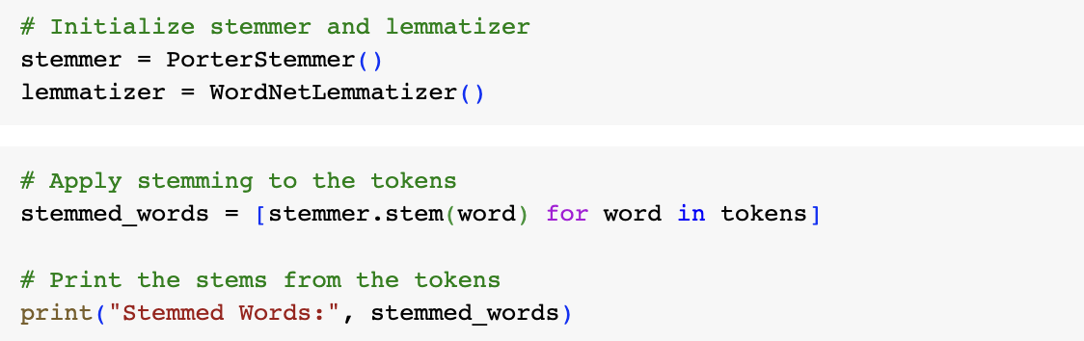
Here, we initialise a stemmer and a lemmatiser because they have to do with rules; as such, a sort of word dictionary that helps define suffixes, prefixes, and root words is required.

- Apply lemmatisation to the tokens
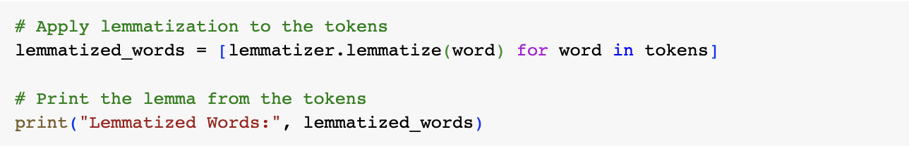

Extra Exercise.
Convert the sample document from task 7 into a numerical representation (i.e., vectorisation).
- Using Bag of Words (BoW)
- Using Term Frequency-Inverse Document Frequency (TF-IDF)

Metadata and labelling for text data

- Create metadata for the processed text data.
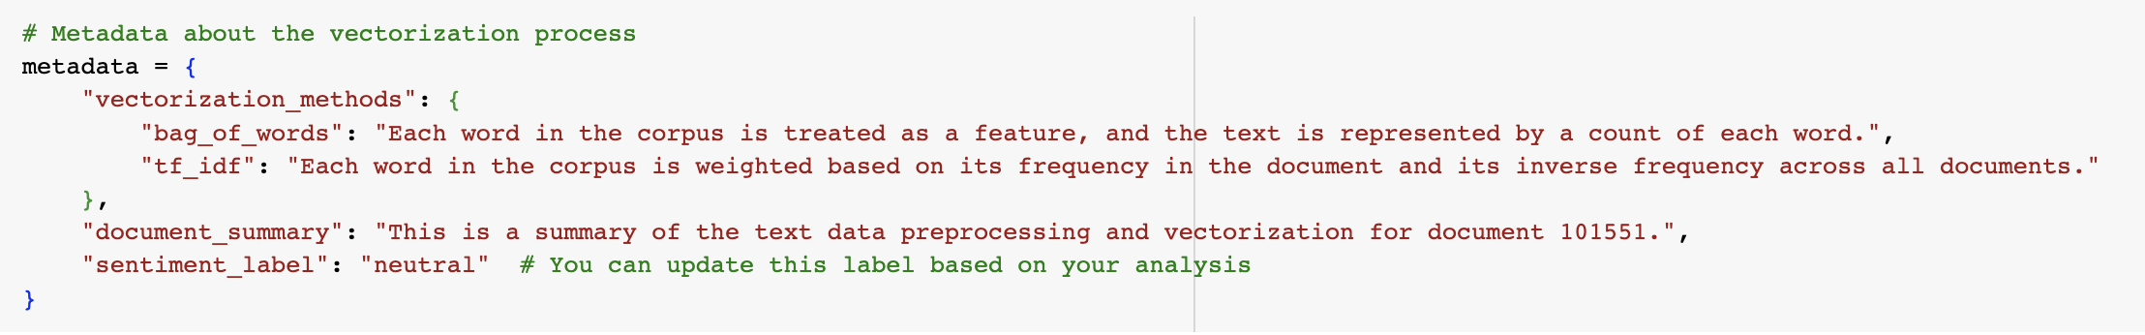
Here, we created a metadata document explaining the vectorisation process and labelled the text data.

- Save the metadata file for the text data as a JSON file.

